NFT Contract Changes

Current NFT website: <http://kickscammersnft.com/>

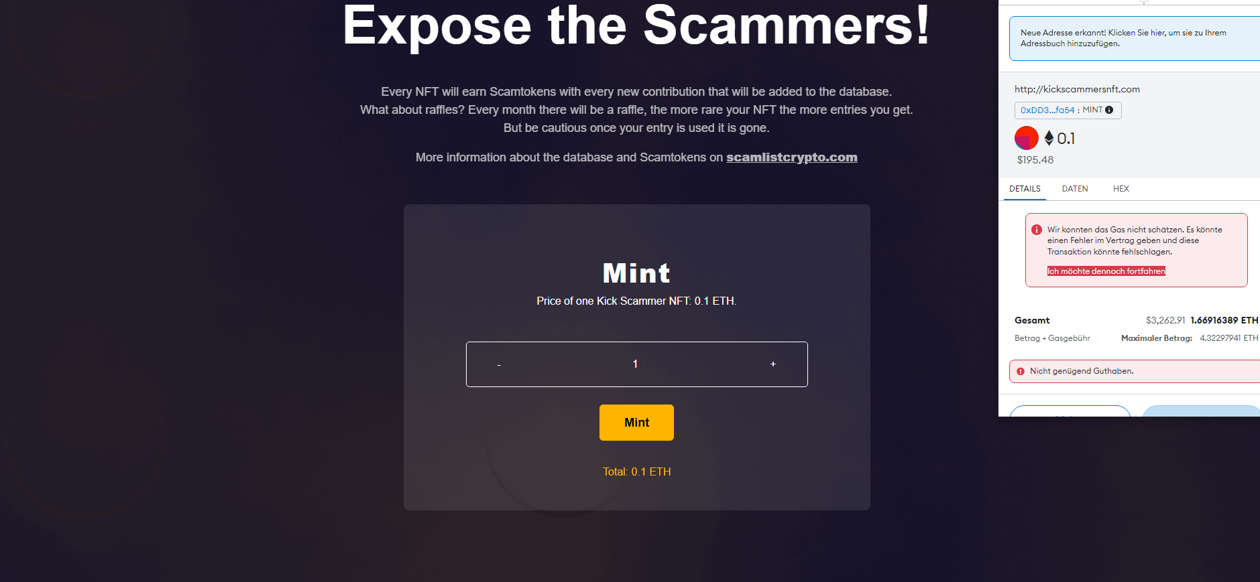

WRONG NAME and Picture ON OPENSEA

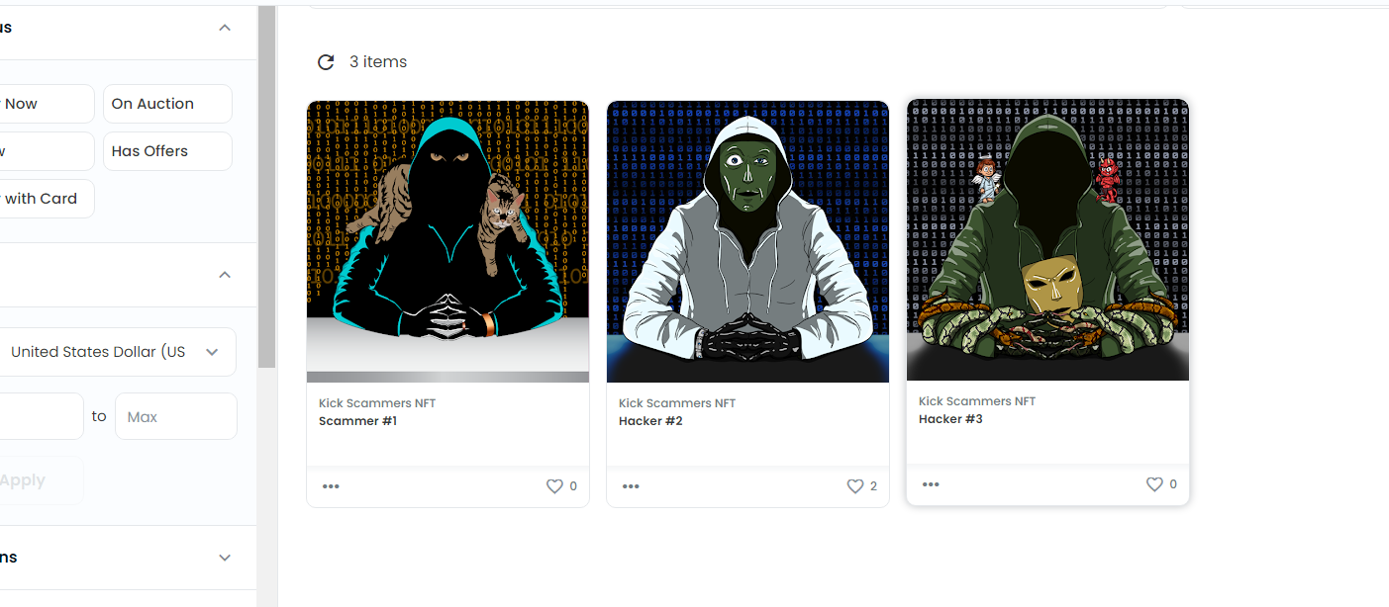

Also add Opensea link after purchase.

When the purchase is done I need a pop-up message where is written:

Purchase done.

Have a look on it at opensea/here should be the link from the collection on opensea.